Correlational analysis between bitcoin, ethereum and ripple

The closing price of the three currencies have been depicted from 2016-2017

Closing price of Bitcoin :

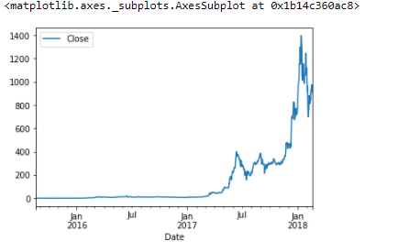

Closing price of ripple :

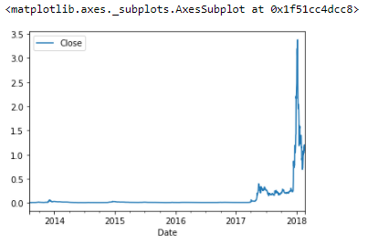

Closing price of ethereum :

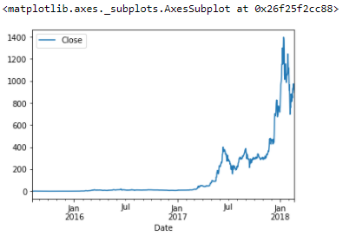

At first glance they all seem to follow a similar pattern , sharp spike from july 2017-jan 2018 , but this cannot confirm any linear relationship between the three , hence correlation analysis is done .

**Pearson’s Correlation**

Depending on the value of the coefficient , we can determine if the three currencies are linearly related.

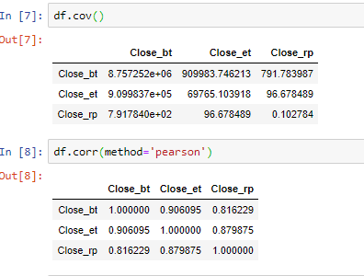

As depicted above , the coefficient between bitcoin and ether is 0.90 approx and between bitcoin and ripple is 0.81 approx , both suggesting that a linear relationship exists. It has been observed that the price of bitcoin tends to change first , either increase or decrease and the other two currencies fill follow that direction more or less.